## **Week 4 Homework Submission File: Linux Systems Administration**

### **Step 1: Ensure/Double Check Permissions on Sensitive Files**

1. Permissions on /etc/shadow should allow only root read and write access.  
   * Command to inspect permissions: ls -l /etc/shadow
   * Command to set permissions (if needed): sudo chmod 600 /etc/shadow
2. Permissions on /etc/gshadow should allow only root read and write access.  
   * Command to inspect permissions: ls -l /etc/gshadow
   * Command to set permissions (if needed): sudo chmod 600 /etc/gshadow
3. Permissions on /etc/group should allow root read and write access, and allow everyone else read access only.  
   * Command to inspect permissions: ls -l /etc/group
   * Command to set permissions (if needed): sudo chmod 604 /etc/group
4. Permissions on /etc/passwd should allow root read and write access, and allow everyone else read access only.  
   * Command to inspect permissions: ls -l /etc/passwd
   * Command to set permissions (if needed): sudo chmod 604 /etc/passwd

### **Step 2: Create User Accounts**

1. Add user accounts for sam, joe, amy, sara, and admin.  
   * Command to add each user account (include all five users):
   * sudo adduser sam
   * sudo adduser joe
   * sudo adduser amy
   * sudo adduser sara
   * sudo adduser admin
2. Force users to create 16-character passwords incorporating numbers and symbols.  
   * Command to edit pwquality.conf file: sudo nano pwquality.conf
   * Updates to configuration file: minlen to 16, dcredit to 1, ocredit to 1, minclass to 2
3. Force passwords to expire every 90 days.  
   * Command to to set each new user's password to expire in 90 days (include all five users):
   * sudo passwd -x 90 sam
   * sudo passwd -x 90 joe
   * sudo passwd -x 90 amy
   * sudo passwd -x 90 sara
   * sudo passwd -x 90 admin
4. Ensure that only the admin has general sudo access.  
   * Command to add admin to the sudo group: sudo usermod -aG sudo admin

### **Step 3: Create User Group and Collaborative Folder**

1. Add an engineers group to the system.  
   * Command to add group: sudo addgroup engineers
2. Add users sam, joe, amy, and sara to the managed group.  
   * Command to add users to engineers group (include all four users):
   * sudo usermod -aG engineers sam
   * sudo usermod -aG engineers joe
   * sudo usermod -aG engineers amy
   * sudo usermod -aG engineers sara
3. Create a shared folder for this group at /home/engineers.  
   * Command to create the shared folder: sudo mkdir -p /home/engineers/shared
4. Change ownership on the new engineers' shared folder to the engineers group.  
   * Command to change ownership of engineer's shared folder to engineer group: sudo chown engineers:engineers /home/engineers/shared

### **Step 4: Lynis Auditing**

1. Command to install Lynis: sudo apt install lynis
2. Command to see documentation and instructions: man lynis
3. Command to run an audit: sudo lynis audit system
4. Provide a report from the Lynis output on what can be done to harden the system.  
   * Screenshot of report output: 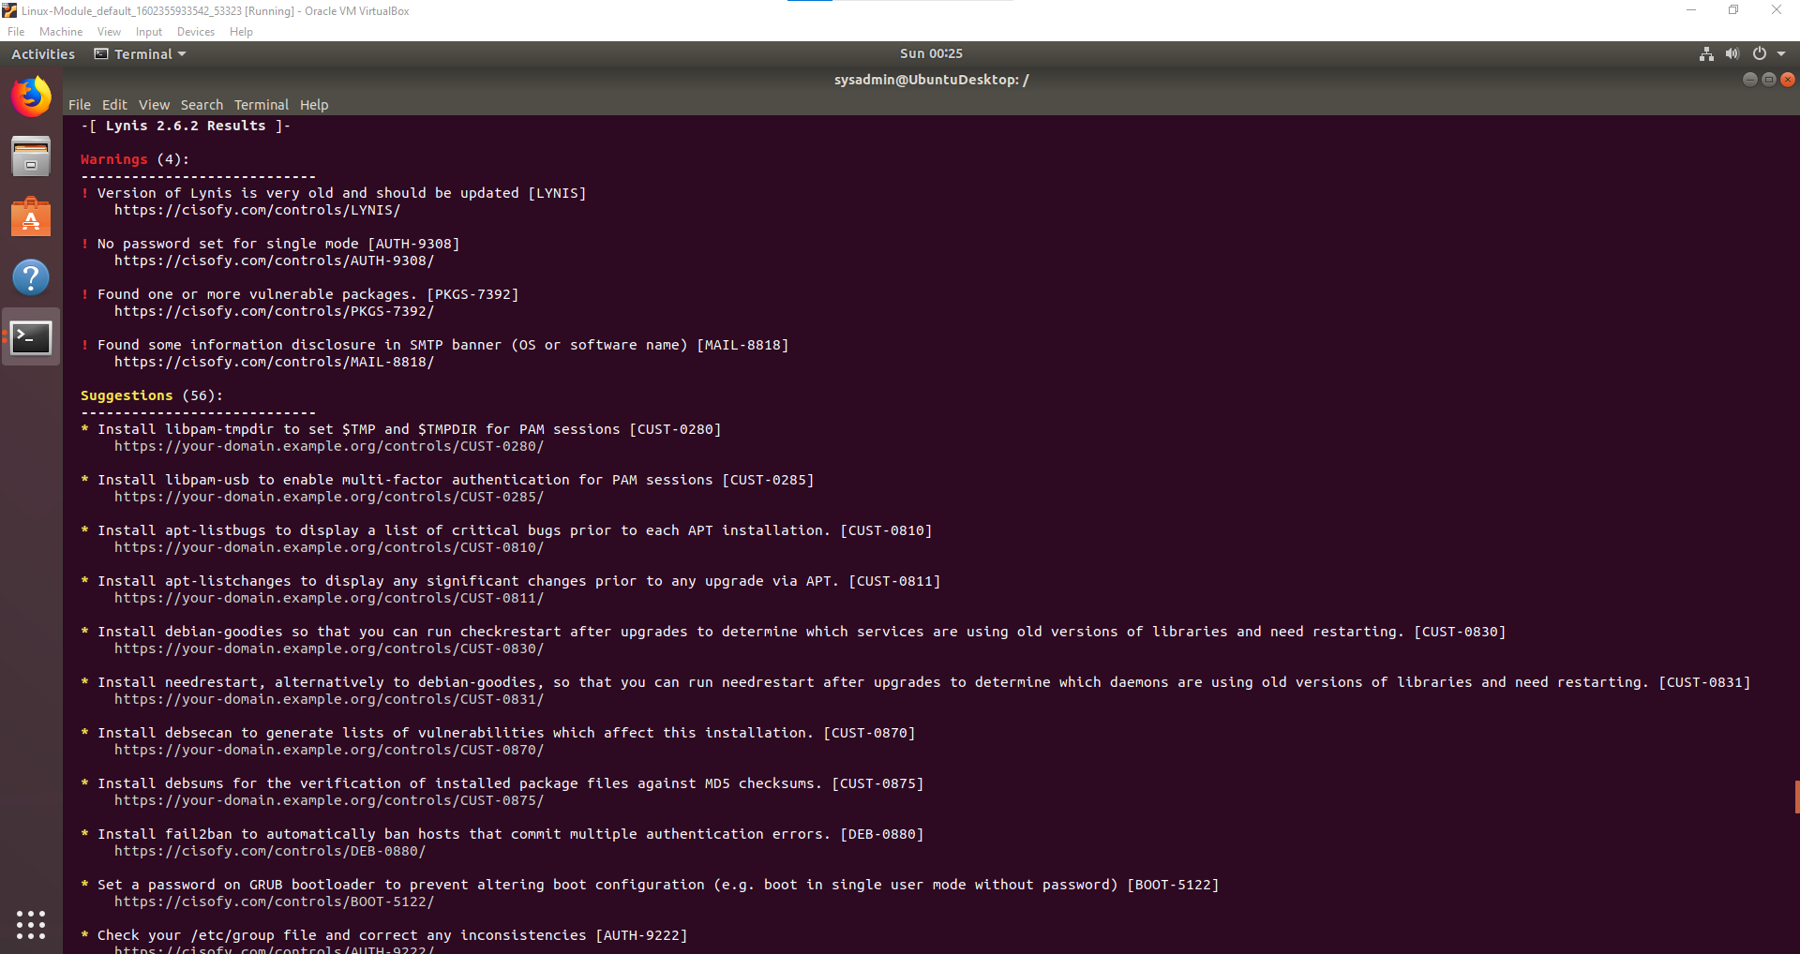
   * 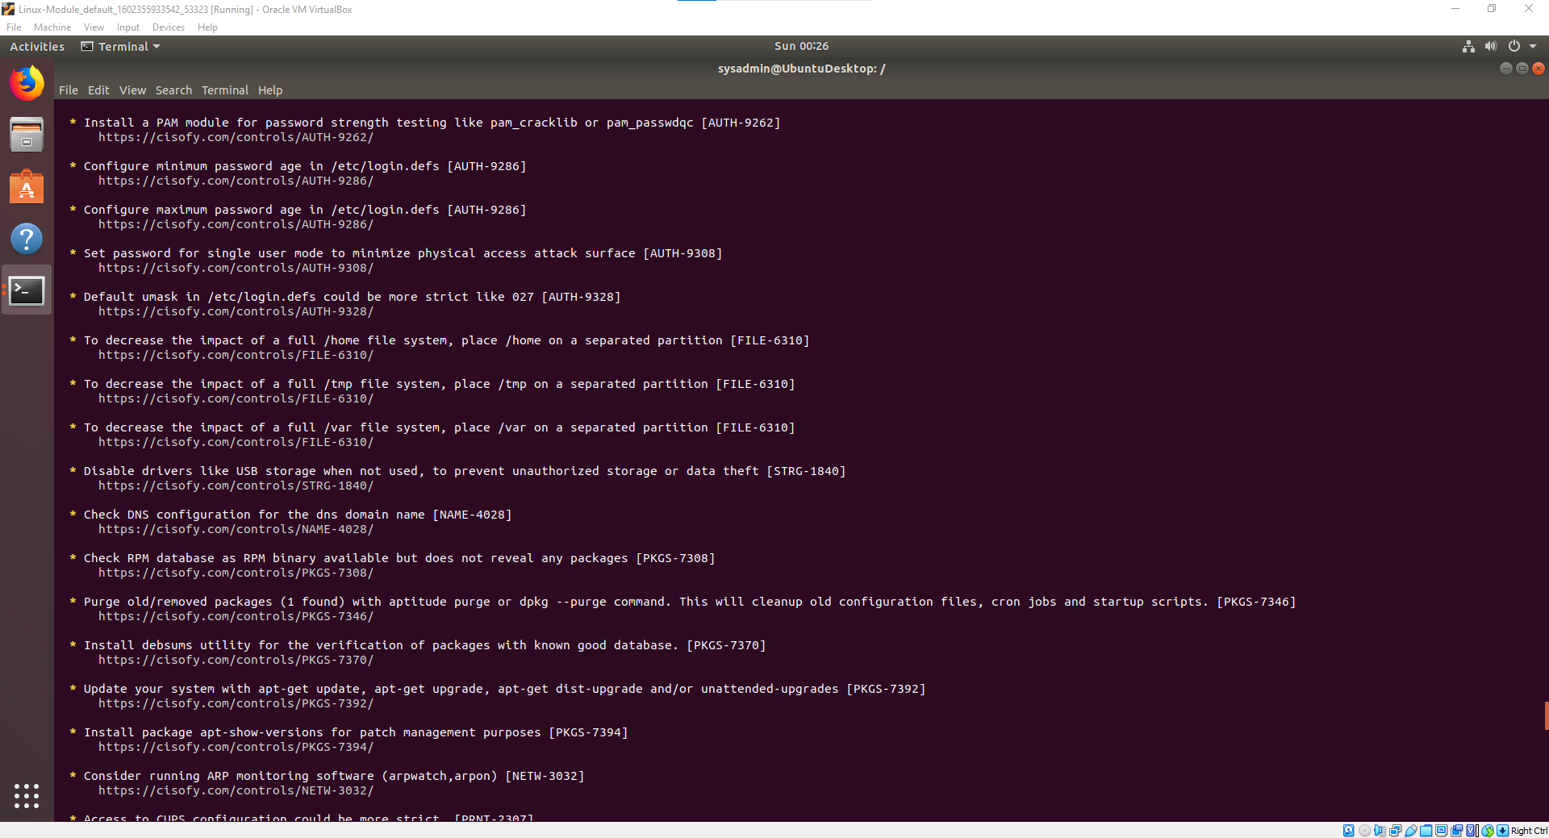
   * 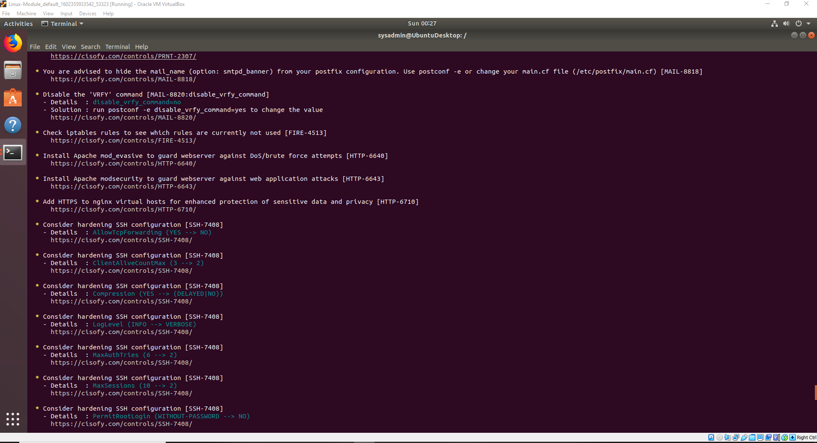
   * 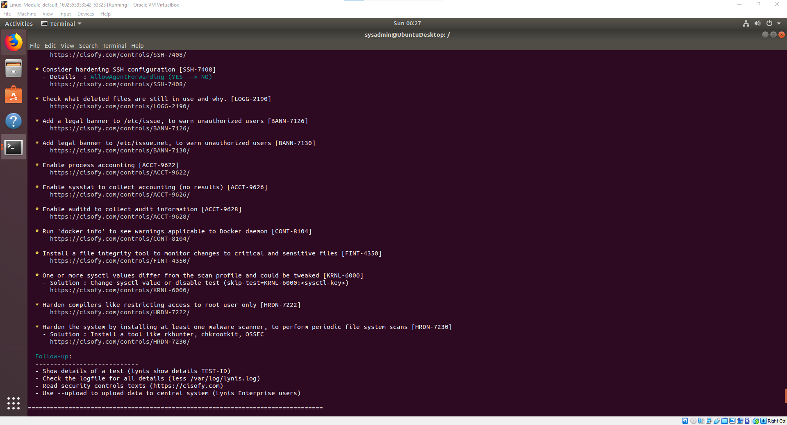
   * 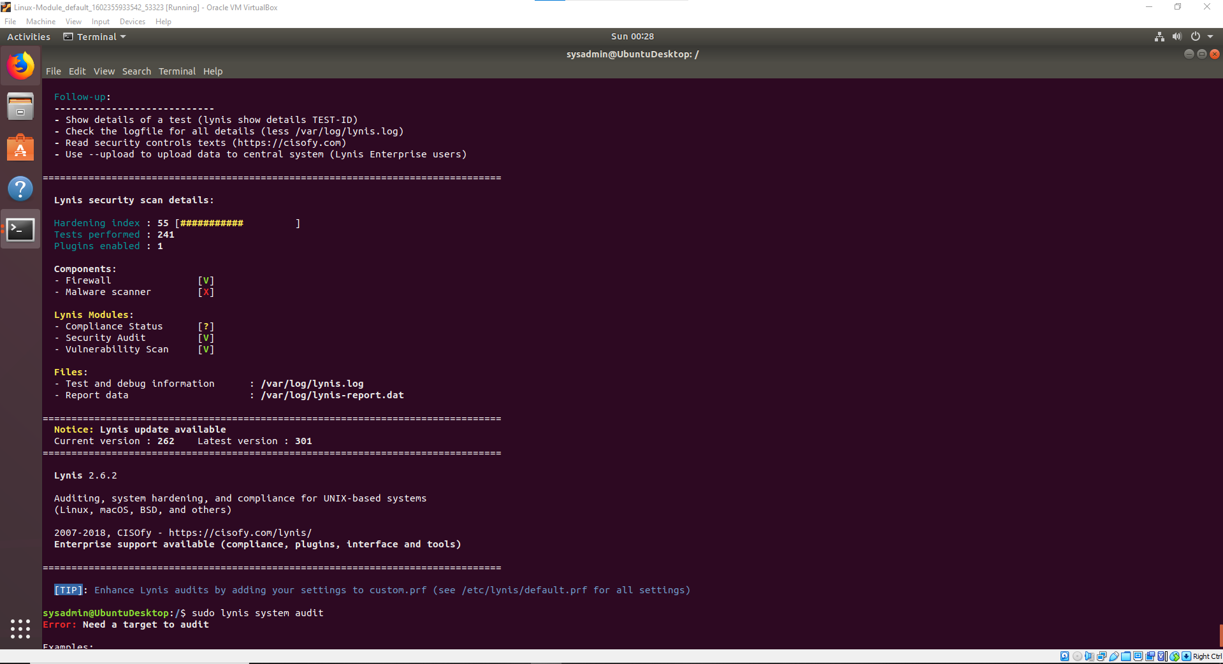

### **Bonus**

1. Command to install chkrootkit: sudo apt install chkrootkit
2. Command to see documentation and instructions: man chkrootkit
3. Command to run expert mode: sudo chkrootkit -x
4. Provide a report from the chrootkit output on what can be done to harden the system.  
   * Screenshot of end of sample output: 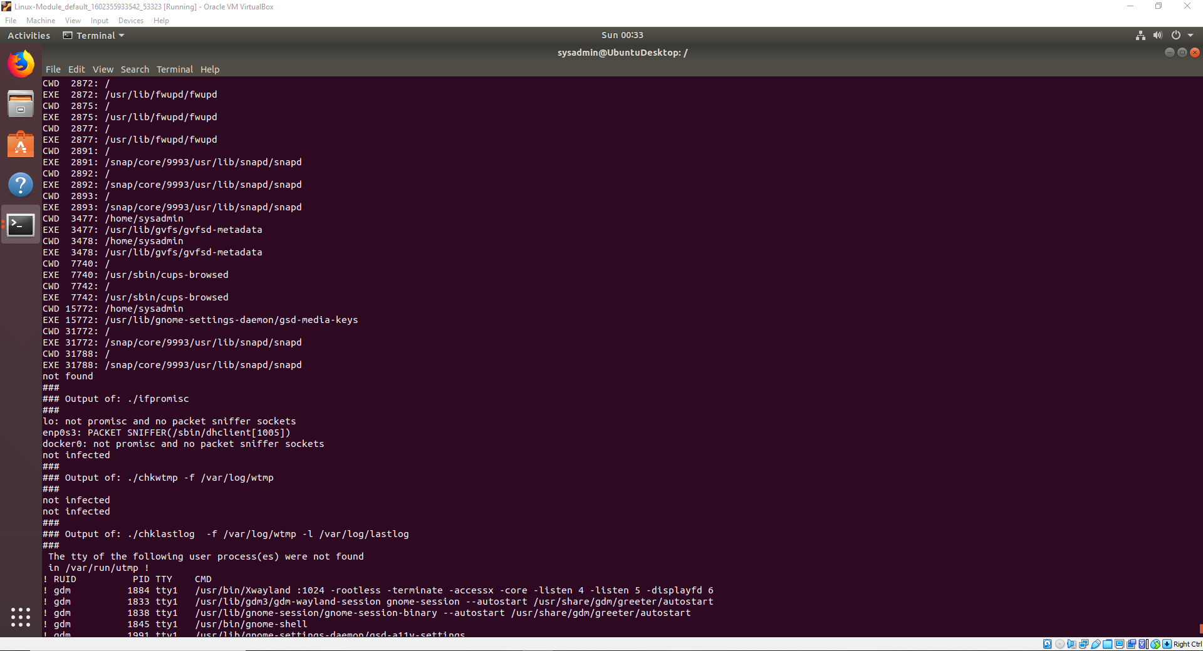
   * 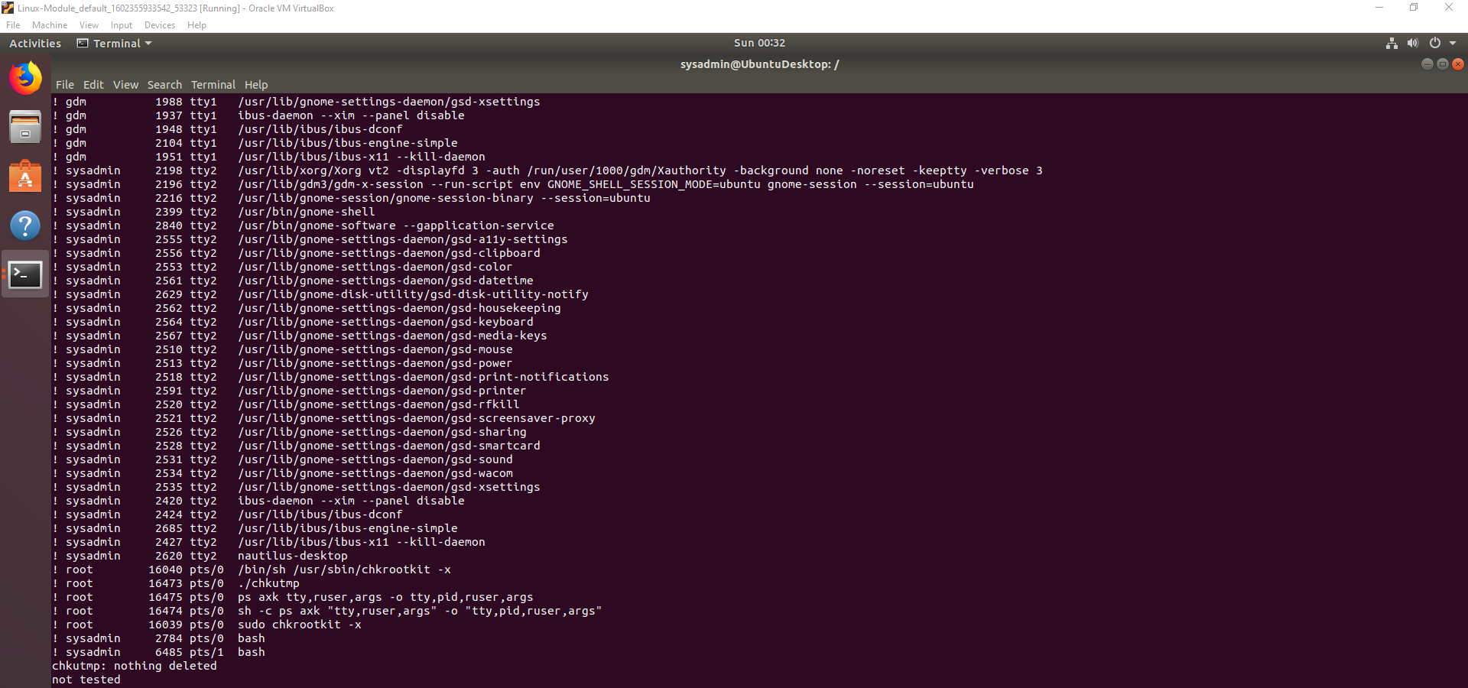

© 2020 Trilogy Education Services, a 2U, Inc. brand. All Rights Reserved.